**In this course you will be programming using a language called Python.**

# **Python**

# Python is an interpreted, object-oriented, high-level programming language with dynamic semantics. Python syntax are easy compared to other languages.

**C language**

#include<stdio.h>

main()

{

printf(“hello world”);

}

Then compile code and run

**Java Language**

public class Test

{

Public static void main(String[] args)

{

System. out.println(“hello world”);

}

}

**Python Language**

print (“hello world”)

python test.py or py test.py (to run code)

Compared to other language it is easiest language. Library support, easiness and concise code python is popular.

**C language**

#include<stdio.h>

main()

{

int a,b;

a=10;

b=20;

printf(“the sum : %d”, (a+b));

**Java Language**

Public Class test

{

Public static void main(String[]args)

{

Int a,b;

A=10;

B=20;

System.out.println(“The sum is : “+(a+b));

}

}

**Python Language**

a=10

b=20

print (‘The sum:’, a+b)

Or a,b = 10,20 Other programing language will not accept it

We are not required to declare int, float etc.

Based on ever provided value automatically type will be considered.

FORTRAN (Formula Translation) =first programming language that is used for the scientific purpose.

**History of Python**

* Python was introduced by Guido van Rossum in 1989 while working in National Research Institute (Netherland). In feb 20th 1991 made available to the public (officially released).
* When he began implementing Python, Guido van Rossum was also reading the published scripts from “Monty Python's Flying Circus”, a BBC comedy series from the 1970s. Van Rossum thought he needed a name that was short, unique, and slightly mysterious, so he **decided to call the language Python**.
* Market trend, Market requirement, it became popular
* Java came in 1995 and officially released in 1996.
* A list of Python versions with its released date is given below.

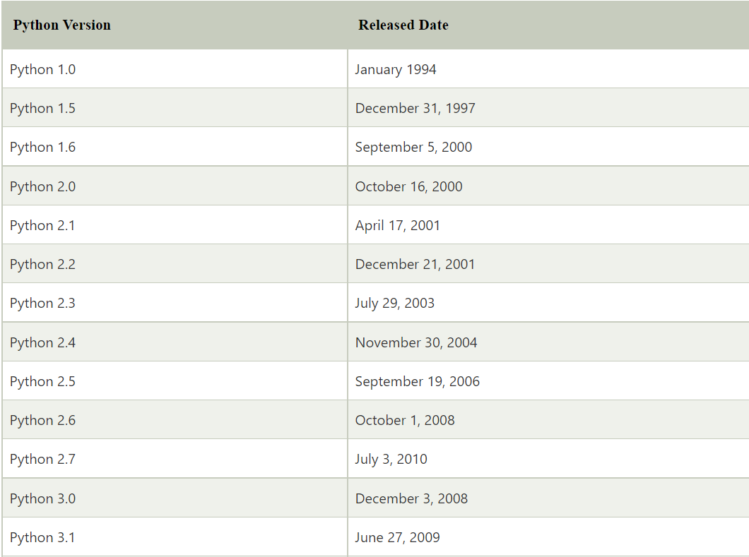

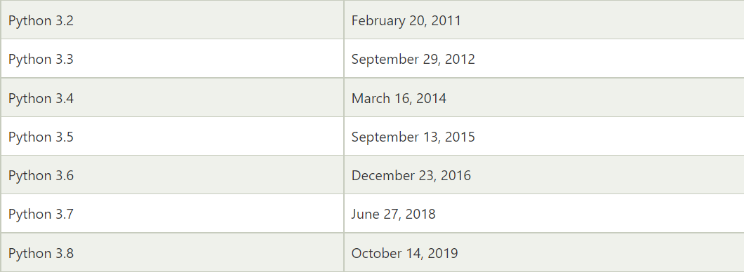

Python 3.9 was released on **October 5th, 2020**.

Python released its latest upgrade, Python 3.10, on **October 04, 2021**.

**Features of Python**

* Easy to learn and implement
* Open source
* Broad Standard Library
* Cross platform
* Work on Interpreter Logic
* High Level Programming
* Extendable Language
* Expressive Programming Language
* GUI Programming Support

**Application of Python**

* Website and Application Development
* Desktop Application
* Games Development
* Data Visualization
* Scientific Calculation
* Machine learning and Artificial Intelligence
* 3D Application Development
* Audio and Videos Software Development like VLC player

**Python Popular Frameworks and Libraries**

* **Web development** – Django Flask, Pyramid, CherryPy
* **GUIs based applications** - Tk, PyGTK, PyQt, PyJs, etc.
* **Machine Learning** - TensorFlow, PyTorch, Scikit-learn, Matplotlib, Scipy, etc.
* **Mathematics** - Numpy, Pandas, etc.

**Companies using Python**

**NETFLIX:** To make video buffering better

**Facebook:** To handle large amount of data

**Dropbox:** To make server-side better

**YouTube:** To make recommend system better

**Instagram:** To make image and video processing better

**Torrent:** To make peer-to-peer connection better

**Is Python compiled or interpreter?**

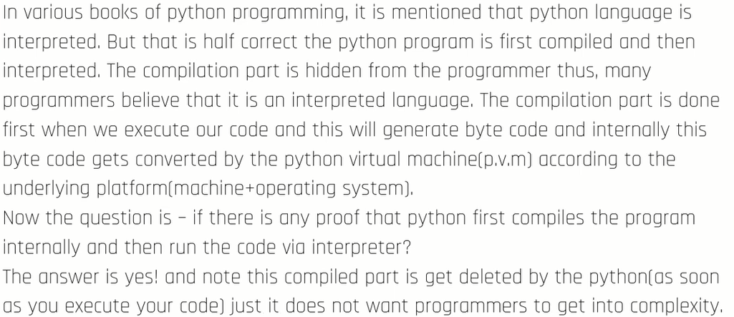

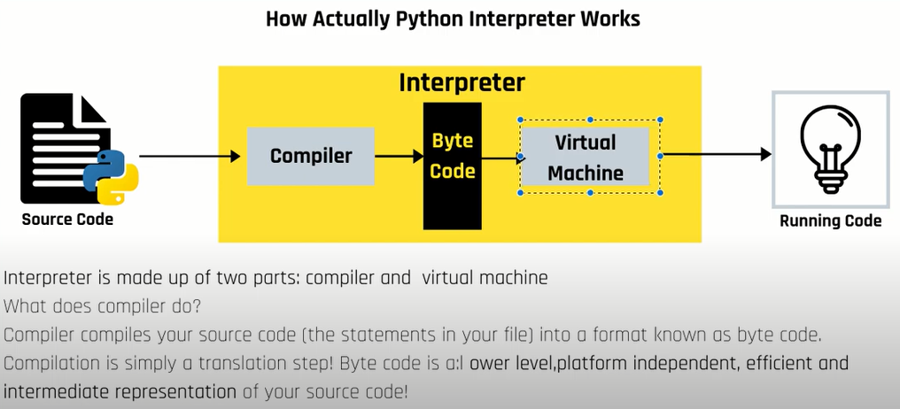

**Byte-Code**

Byte code is an intermediate code or let say it is machine independent code which is not directly run by CPU. Byte code is not directly understandable by CPU. Since Byte code is not directly understandable by the machine, so there might be something to understand bytecode, hence here virtual machine comes into action.

**Virtual Machine**

It is a special layer of software which converts byte-code instructions to machine instructions.

**Benefits of Byte-Code**

Once compiles bytecode can run on any platform, if that platform has virtual machine.

**Drawback of Byte-code**

It run at slower pace because the interpreter inside virtual machine has to convert each bytecode instruction to native form and then sends it for execution to the CPU.